Appendix 1: Examples of work completed during 16/17

Overmead Green
Environmental Improvements to communal garden includes:
bin stores, privacy closed board fencing, drying area, seating areas and two benches, resurfaced paths.

Before After

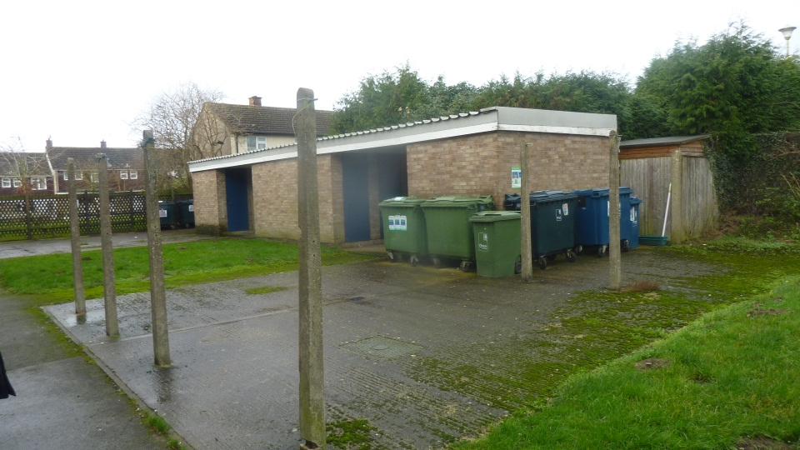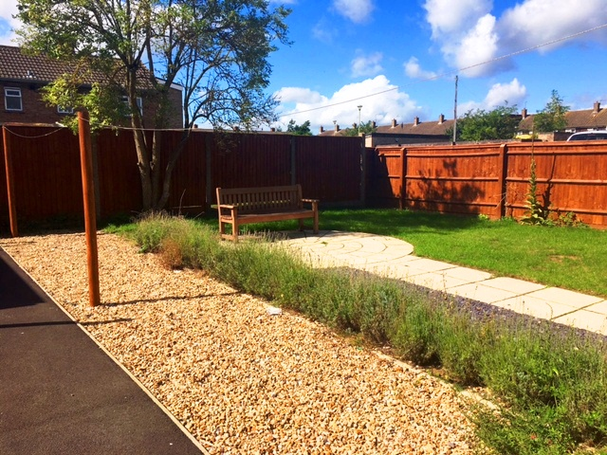

Linnet Close
Environmental Improvements include: refurbishment of drying areas, bin stores, patio area, resurfaced paths, bike racks.

Before After

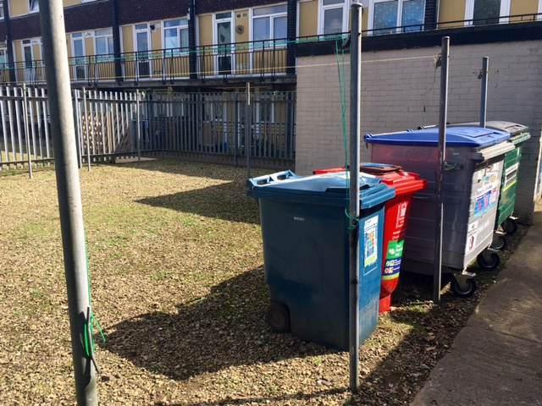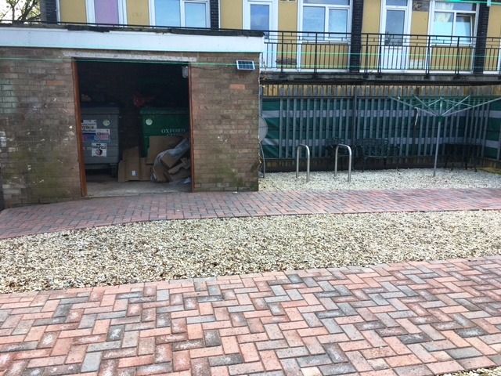

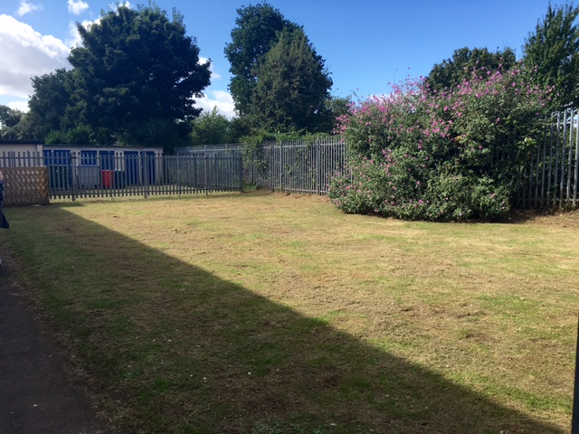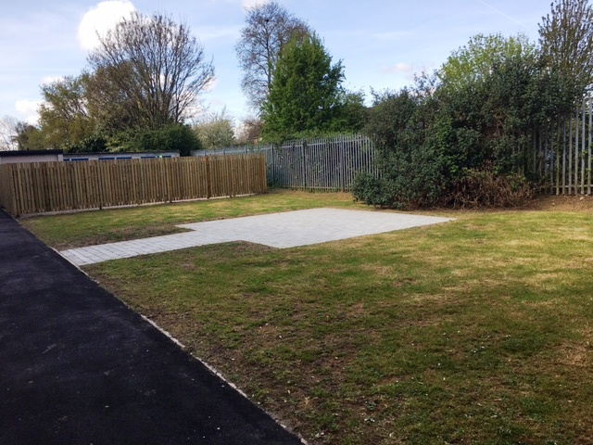

Nelson Street
Communal garden only accessible through resident’s flats. Cleared and divided into separate gardens, paths laid, fences and gates installed, planting bed, and facility for rotary washing line. Residents were given choice of gravel or grass.

Before After

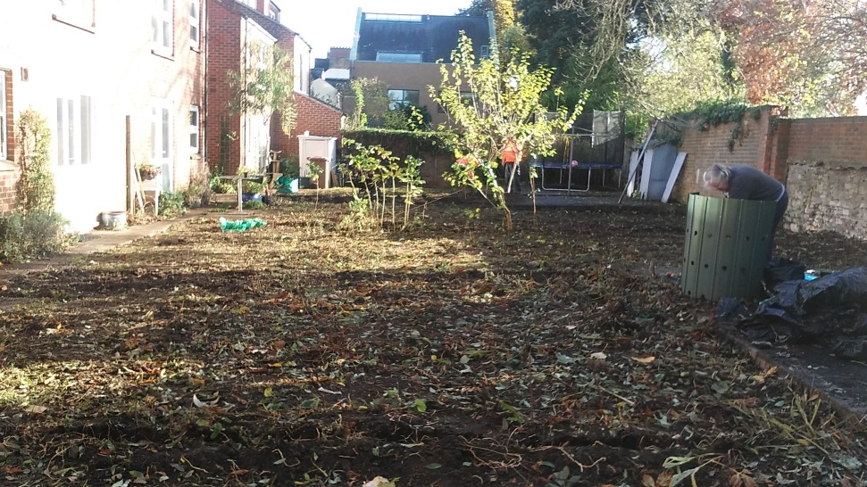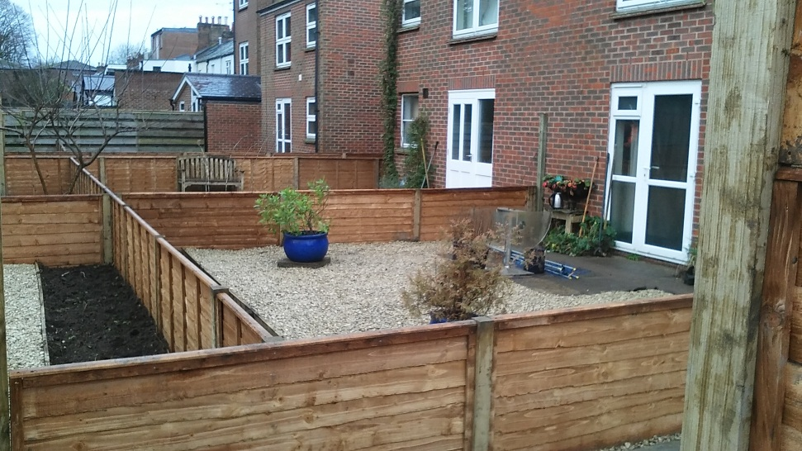

Druce Way and Warburg Crescent
Previously waste and recycling bins kept beneath building in storage shed area, creating a fire hazard. The unsightly and often over flowing refuse also posed an environmental hazard. New lockable bin stores erected and waste chutes sealed.

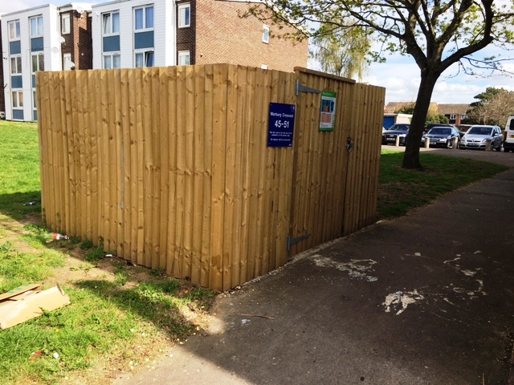

Colemans Hill

Fencing, Signage, Internal Redecoration, Paths overlaid, Anti-slip treads external staircase, Internal Fire Doors,
Vinyl Flooring, Bin Store, Bicycle Storage, Landscaping

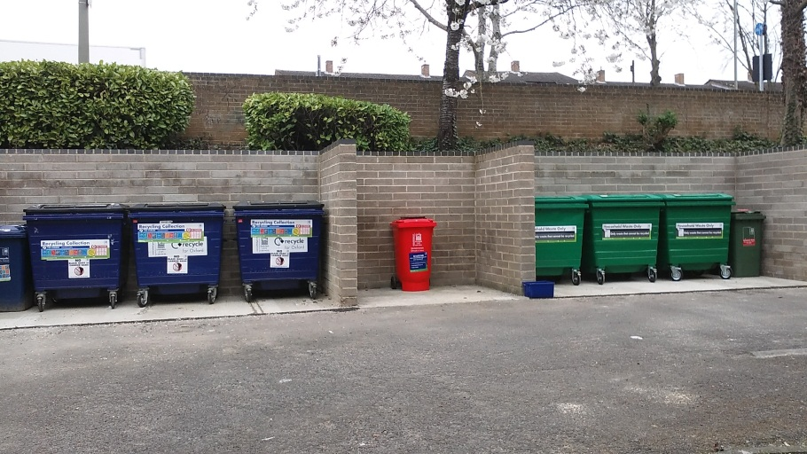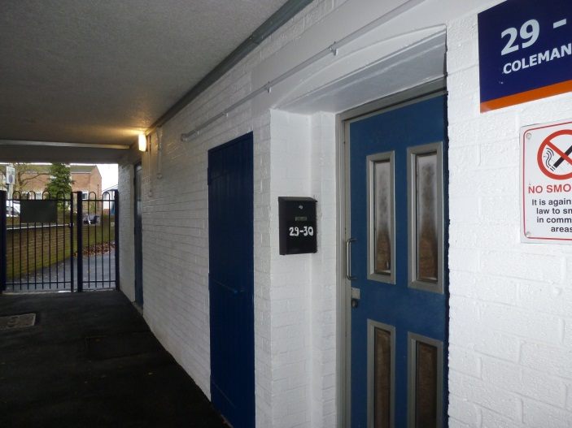

Car Parking

Levelling Carparks in Stowford Road and Taggs Gate, Barton

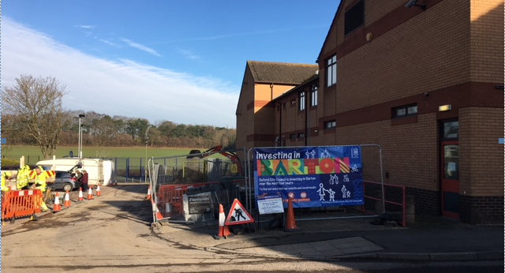

Preachers Lane and Friars Wharf Wireless Door Entry

